**Name –** Sushmita Kumari Gupta

**Assignment** – Power BI [Major]

**Email** – sushmitagupta290@gmail.com

# Course – Business Analyst Career Program (ChatGPT)

**Q1)** Create the dashboard following the general requirements in the dashboard, following sheets are required

1. Three cards for Active, Deaths, and Recovered
2. One visual with Country VS. Deaths and Recovered
3. One visual with WHO region Vs. One week % increase

# Solution-

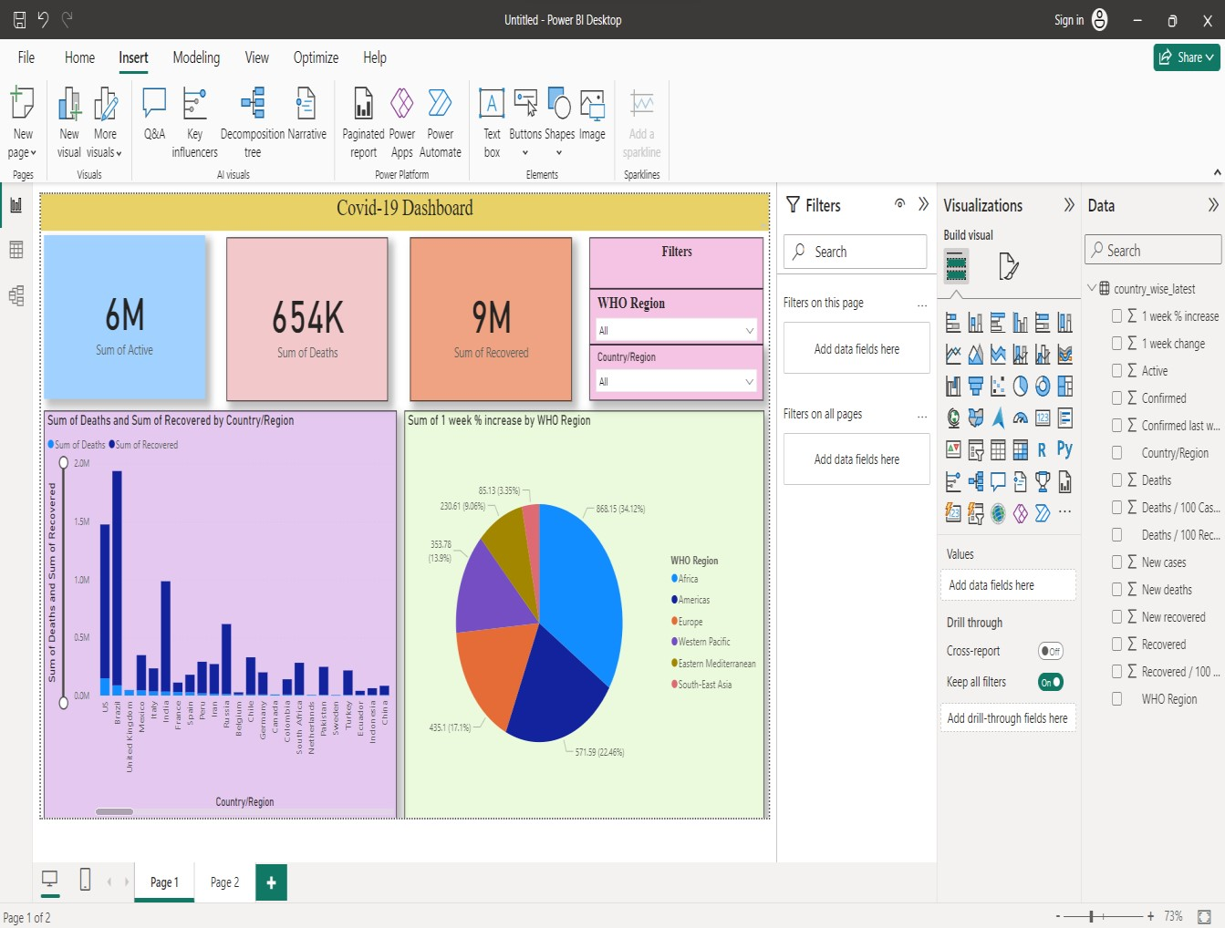

**Q2)** Answer the following questions

1. How many WHO regions?

**Ans)** Sixregions

1. Total new cases from the dataset?

**Ans)** 229K

1. Total Active cases?

# Ans) 6 M

**4)** Which Country has the highest Deaths? **Ans)** US